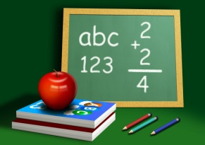 Mathematics 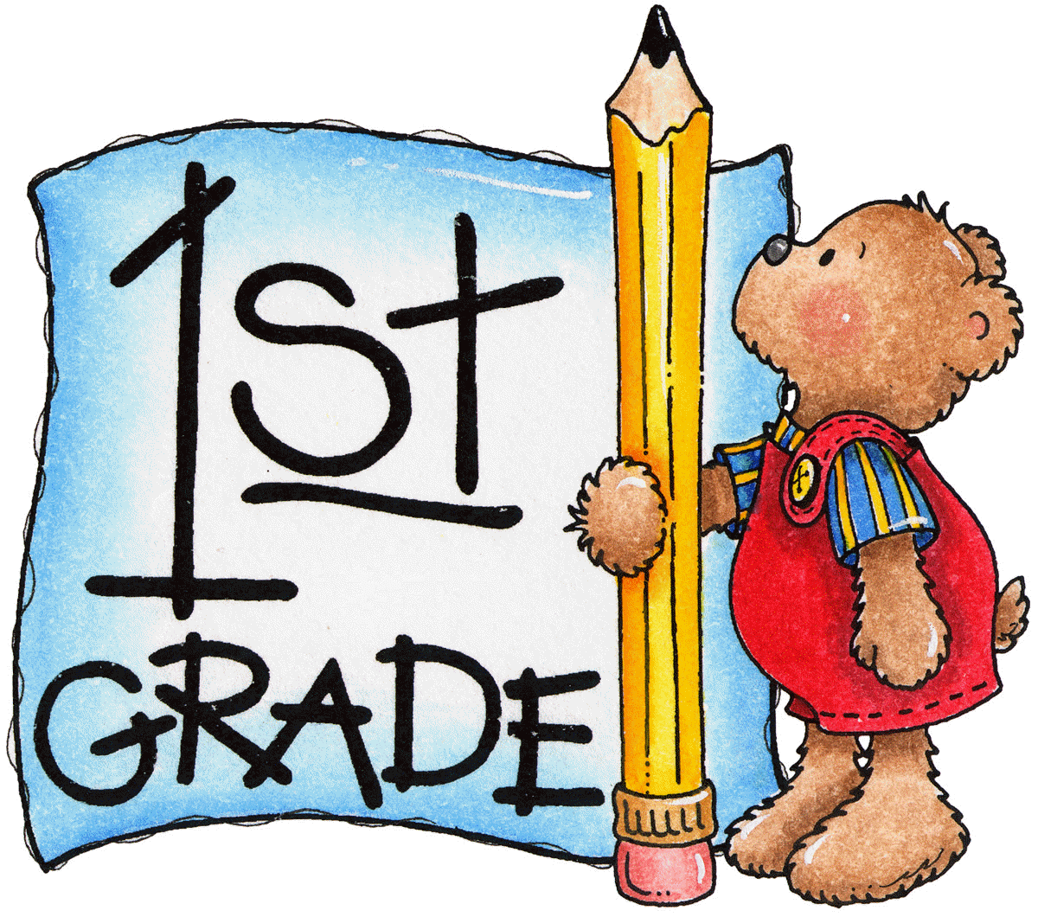

September 2020

Dear Parents,
We continually monitor and evaluate the best placement for your child based upon his/her math progress and level. At this time, your child will be in my math class. The class will be moving at a faster pace and will involve higher level thinking activities and lessons.
Normally, there will be minimal homework in math. However, each student is expected to practice addition and subtraction facts in order to learn the sums and differences. By the end of the year, the goal will be to have each student learn how to add and to subtract correctly and quickly without “finger counting”. Learning these basic facts will definitely help your child in the upper grade levels. Addition and subtraction are the building blocks for math. Your child needs a strong foundation to ensure success later.
I am looking forward to getting to know your child during this year. If you have any further questions, please contact me at Chip_Hines@tccsa.net or (330) 658-2522 ext. 331. Please feel free to view my website, too. www.mrshineslittlechipps.com

Sincerely,
Mrs. Hines

