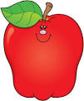 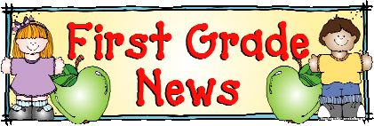 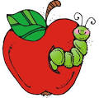

Mrs. Hines’ Reading and Language Arts Class

Reading and Literature

This week, we will be reading and discussing *T’was the Night Before Thanksgiving* by Dav Pilkey. They students will be sequencing (putting events in order) and completing comprehension activities. The students will be engaged in activities that align with their reading level. In addition, they will continue sight word exams. Please practice.

***End of year goals:* Reading Level L and mastery of sight word lists 1- 34**

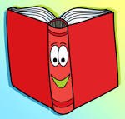

Writing

The students will continue correct letter and number formation. These should be written from top to bottom.

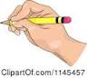

Other Information and Important Dates

Nov. 7th Wear Blue in support of Chippewa Local Schools

Nov. 7th: Voting Day! Remember to vote!

Nov. 23-24: Thanksgiving Vacation – No School

*Please remember to sign your child’s reading log and agenda each evening. It is a great source of communication between home and school. Also, reading daily, helps your child with his/her literacy development and growth.

Email: [Chip_Hines@tccsa.net](mailto:Chip_Hines@tccsa.net)

Phone: (330) 658-2522 ext. 331

Website: http://www.mrshineslittlechipps.com/

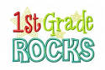

Phonics, Word Study and Spelling

The students will begin spelling. There are five word wall/sight words. In addition, there will be ten more selected from the word families. The word families this week are “et”, “en” and “est”. The students will be writing two sentences that I recite. Please practice writing the words correctly. (Reversals and correct capitalization count!) See the attached list on this site.

