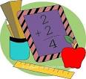  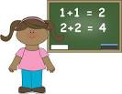

Mrs. Hines’ Math Class

Math

The students will be exploring how addition and subtraction are related. They will be identifying fact families. Then, they will be solving story problems involving addition and subtraction, and identifying all the equations that equal a specific number. Please practice addition flashcards with your child. The goal is to add as quickly as possible without finger counting.



Other Information and Important Dates

Nov. 7th Wear Blue in support of Chippewa Local Schools

Nov. 7th: Voting Day! Remember to vote!

Nov. 23-24: Thanksgiving Vacation – No School

Email: [Chip_Hines@tccsa.net](mailto:Chip_Hines@tccsa.net)

Phone: (330) 658-2522 ext. 331

Website: http://www.mrshineslittlechipps.com/

