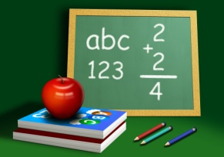 Mathematics 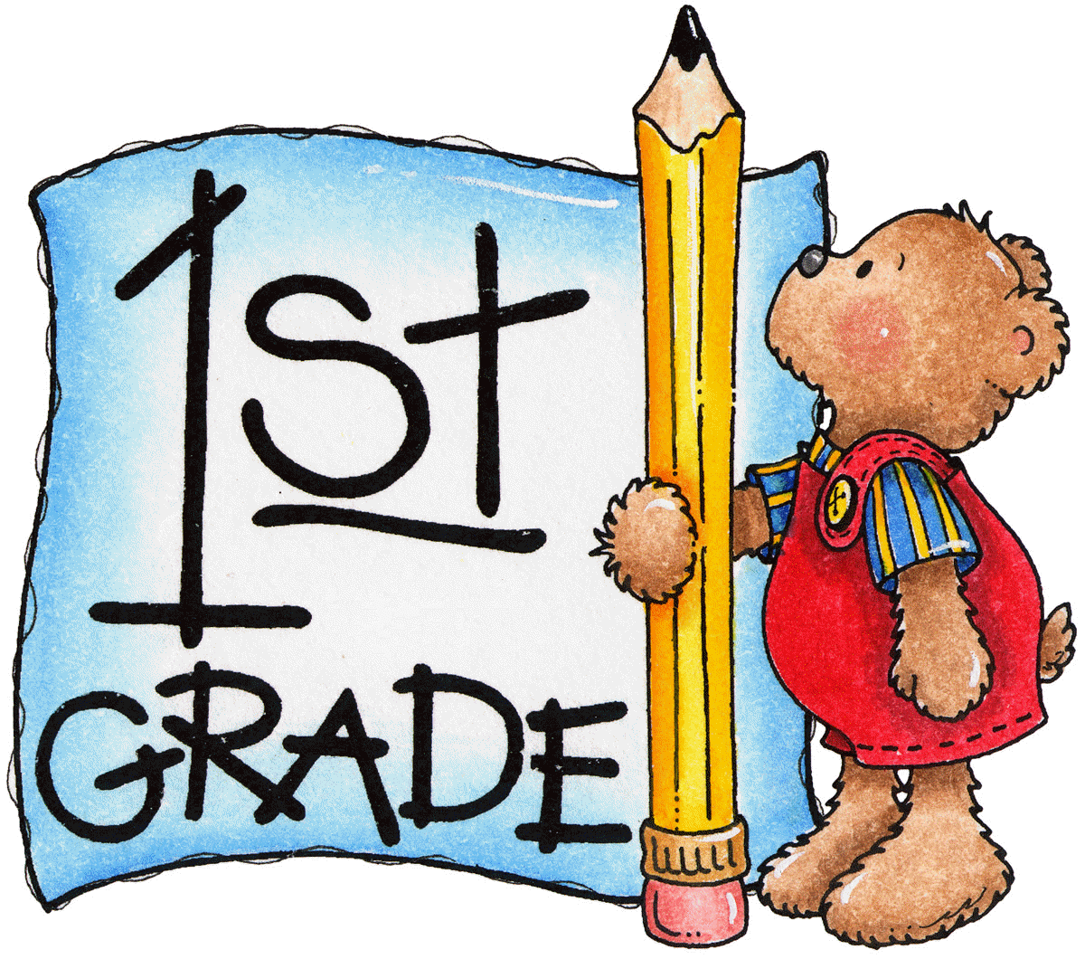

Dear Parents,
Normally, there will be minimal homework in math. However, each student is expected to practice addition and subtraction facts in order to learn the sums and differences. By the end of the year, the goal will be to have each student learn how to add and to subtract correctly and quickly without “finger counting”. Learning these basic facts will definitely help your child in the upper grade levels. Addition and subtraction are the building blocks for math. Your child needs a strong foundation to ensure success later.
Also, please practice counting coins (pennies, nickels, dimes, and quarters) and telling time (hour and half hour). These are important life skills.
When school and home work together, children will be successful. I love seeing children learn and continue to want to grow academically.
I am looking forward to getting to know your child during this year. If you have any further questions, please contact me at jeanne.hines@chippewaschools.com or (330) 658-2522 ext. 3008. Please feel free to view my website, too. www.mrshineslittlechipps.com

Sincerely,
Mrs. Hines

